Morgan County Indiana Precinct Committeemen
(Effective 8/24/2024)
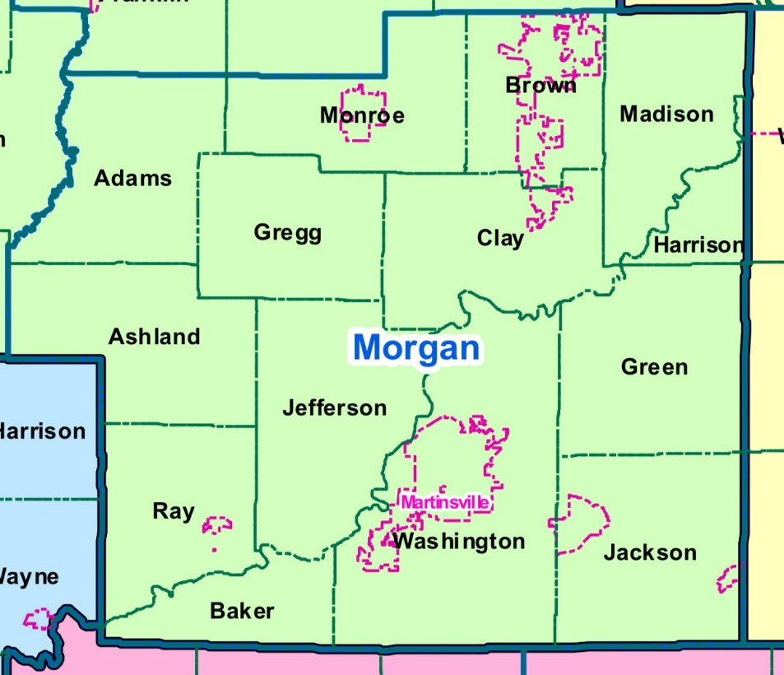

Adams
Adams Linda Pruitt 765-341-0425 linda.pruitt67@yahoo.com

Ashland
Ashland Rich Myers 765-346-0863 rmeyers259@gmail.com

Baker
Baker Jerry Hodges 765-346-0310 jfhodges1948@gmail.com

Brown
Brown 1 Sandra Perry 317-445-1943 srperry42@gmail.com
Brown 2 Pamela Siddons 317-834-9890 siddonsp@yahoo.com
Brown 3 Jason Maxwell 765-346-0045 badfarmer4@gmail.com
Brown 4 Diana Wamsley 317-831-7451 diannawamsley@gmail.com
Brown 5 Greg Swinney 317-538-9896 gswinney@Mooresville.in.gov

Brown 6 Josh Messmer 765-341-0223 Jmessmer@morgancounty.in.gov
Brown 7 Karen Overpeck 317-690-2367 karen.overpeck1958@gmail.com
Brown 8 Don Adams 317-670-0929 bethelpond@gmail.com

Clay
Clay 1 Jacob Thacker 765-318-1116 j_thacker23@hotmail.com
Clay 2 Bill Mitchell 317-441-5539
Clay 3 Kristi Dunigan 765-346-8867 kristi.dunigan2013@gmail.com

Green
Green 1 Jon Fletcher 765-315-8930
Green 2 Daniel Elliott 317-517-6813 delliott1@tos.in.gov

Gregg
Gregg 1 Carole Snyder 317-410-0375 carolesnyder810@gmail.com
Gregg 2 David Rogers 317-730-5785 drogers5785@gmail.com

Harrison
Harrison Terri White 317-446-8045 twhite3612@aol.com

Jackson
Jackson 1 Tom Carter 765-315-9682 t-dcarter@att.net
Jackson 2 Jay Hart 615-779-6140 hartindy@gmail.com
Jackson 3 Courtney Allen 812-322-5067
Jefferson
Jefferson 1 Ann Lankford 317-442-0779 goardgal40@gmail.com
Jefferson 2 Kenny Hale 765-318-3390 kennyhale4commissioner@gmail.com

Madison
Madison 1 Angie Turley 317-797-0615 angie.turley21@gmail.com
Madison 2 Candy McCormick 765-748-1329
Madison 3 Terry Brock 317-840-0580 mobrock4@aol.com
Madison 4 Kenny Johnson 317-716-2117
Madison 5 Denise McClure 708-805-4370 adm.dmcclure@gmail.com
Madison 6 Tina Turner 317-508-4584 tmturner4584@gmail.com

Monroe
Monroe 1 Diane Hubbard 317-414-7245 tdh8830@aol.com
Monroe 2 Loren Moore 317-372-2538 limoore@ccrtc.com
Monroe 3 Debra Dotson 317-517-7327 dpdotson@hotmail.com

Ray
Ray 1 Mike Ellis 812-821-0149 mike0652@gmail.com
Ray 2 Ron Burnett 765-341-1747 ronburnett88@gmail.com

Washington
Washington 1 Ben Merida 765-352-2996 bnmerida@gmail.com
Washington 2 Shawn Clark 765-343-2726 tjacksmom08@gmail.com
Washington 3 Phil Deckard II 765-342-0406 pdeckard@scican.net
Washington 4 Brad Wilson 765-346-0942 branette@comcast.net
Washington 5 Jonathan Collier 765-516-5076
Washington 6 Rod Bray 317-372-7186 rbray1969@att.net
Washington 7 Terry Clelland 317-840-2552 tldalton61@yahoo.com
Washington 8 Kim Merideth 765-318-1369 kmerideth@mayfieldinsurance.com
Washington 9 Tammy Parker 765-318-0069 tparker@morgancounty.in.gov
Washington 10 Peggy Mayfield 765-346-9666 peggy@peggymayfield.com

